Joe Merrill
20 APR 2026
CMSC 451 Homework 5

1. Prim's minimum spanning tree algorithm starting at F

Mermaid.js code for one weighted graph consistent with Problem 1:
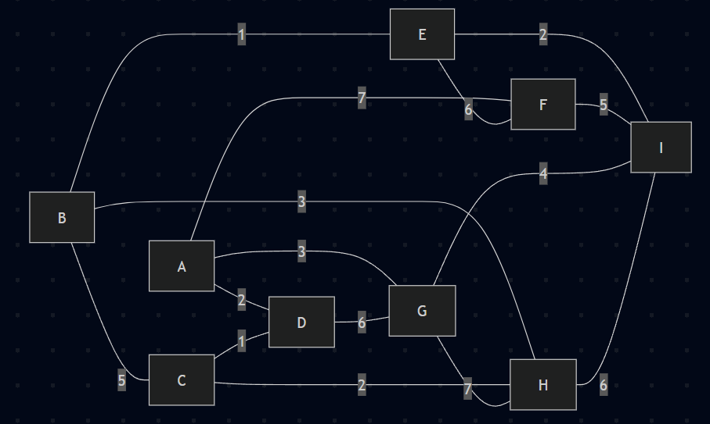
Initial tree:

T = {F}

Initial fringe distances:

A: 7 via F
E: 6 via F
I: 5 via F

Step 1:
Choose I because it has the smallest fringe distance, 5.
Add FI(5) to the minimum spanning tree.

Distance updates:
E: 6 -> 2 via I
G: infinity -> 4 via I
H: infinity -> 6 via I

Current fringe:
A: 7 via F
E: 2 via I
G: 4 via I
H: 6 via I

Step 2:
Choose E because it has the smallest fringe distance, 2.
Add IE(2) to the minimum spanning tree.

Distance updates:
B: infinity -> 1 via E

Current fringe:
A: 7 via F
B: 1 via E
G: 4 via I
H: 6 via I

Step 3:
Choose B because it has the smallest fringe distance, 1.
Add EB(1) to the minimum spanning tree.

Distance updates:
H: 6 -> 3 via B
C: infinity -> 5 via B

Current fringe:
A: 7 via F
C: 5 via B
G: 4 via I
H: 3 via B

Step 4:
Choose H because it has the smallest fringe distance, 3.
Add BH(3) to the minimum spanning tree.

Distance updates:
C: 5 -> 2 via H

Current fringe:
A: 7 via F
C: 2 via H
G: 4 via I

Step 5:
Choose C because it has the smallest fringe distance, 2.
Add HC(2) to the minimum spanning tree.

Distance updates:
D: infinity -> 1 via C

Current fringe:
A: 7 via F
D: 1 via C
G: 4 via I

Step 6:
Choose D because it has the smallest fringe distance, 1.
Add CD(1) to the minimum spanning tree.

Distance updates:
A: 7 -> 2 via D
G stays 4 because DG = 6 is not better

Current fringe:
A: 2 via D
G: 4 via I

Step 7:
Choose A because it has the smallest fringe distance, 2.
Add DA(2) to the minimum spanning tree.

Distance updates:
G: 4 -> 3 via A

Current fringe:
G: 3 via A

Step 8:
Choose G because it has the smallest fringe distance, 3.
Add AG(3) to the minimum spanning tree.

Final minimum spanning tree edges in order:

FI(5), IE(2), EB(1), BH(3), HC(2), CD(1), DA(2), AG(3)

Final minimum spanning tree:

{FI, IE, EB, BH, HC, CD, DA, AG}

Total weight:

5 + 2 + 1 + 3 + 2 + 1 + 2 + 3 = 19

2. Kruskal's algorithm

Priority queue order by nondecreasing weight, alphabetical within equal weights:

DM(1), GH(1), JM(1), EJ(2), HM(2), DF(3), FM(3), KL(3), AD(4), BC(4),
CM(5), EF(5), GM(5), JK(5), DE(6), IM(7), AC(8), GI(8), HK(8), BM(9),
EM(9), LM(9), HI(10), KM(10), AB(11), BG(12), AM(13)

Initial dynamic equivalence relation:

{A} {B} {C} {D} {E} {F} {G} {H} {I} {J} {K} {L} {M}

1. Remove DM(1): add it to the tree
Equivalence relation:
{A} {B} {C} {D,M} {E} {F} {G} {H} {I} {J} {K} {L}

2. Remove GH(1): add it to the tree
Equivalence relation:
{A} {B} {C} {D,M} {E} {F} {G,H} {I} {J} {K} {L}

3. Remove JM(1): add it to the tree
Equivalence relation:
{A} {B} {C} {D,J,M} {E} {F} {G,H} {I} {K} {L}

4. Remove EJ(2): add it to the tree
Equivalence relation:
{A} {B} {C} {D,E,J,M} {F} {G,H} {I} {K} {L}

5. Remove HM(2): add it to the tree
Equivalence relation:
{A} {B} {C} {D,E,G,H,J,M} {F} {I} {K} {L}

6. Remove DF(3): add it to the tree
Equivalence relation:
{A} {B} {C} {D,E,F,G,H,J,M} {I} {K} {L}

7. Remove FM(3): skip it because F and M are already in the same equivalence class
Equivalence relation:
{A} {B} {C} {D,E,F,G,H,J,M} {I} {K} {L}

8. Remove KL(3): add it to the tree
Equivalence relation:
{A} {B} {C} {D,E,F,G,H,J,M} {I} {K,L}

9. Remove AD(4): add it to the tree
Equivalence relation:
{A,D,E,F,G,H,J,M} {B} {C} {I} {K,L}

10. Remove BC(4): add it to the tree
Equivalence relation:
{A,D,E,F,G,H,J,M} {B,C} {I} {K,L}

11. Remove CM(5): add it to the tree
Equivalence relation:
{A,B,C,D,E,F,G,H,J,M} {I} {K,L}

12. Remove EF(5): skip it because E and F are already in the same equivalence class
Equivalence relation:
{A,B,C,D,E,F,G,H,J,M} {I} {K,L}

13. Remove GM(5): skip it because G and M are already in the same equivalence class
Equivalence relation:
{A,B,C,D,E,F,G,H,J,M} {I} {K,L}

14. Remove JK(5): add it to the tree
Equivalence relation:
{A,B,C,D,E,F,G,H,J,K,L,M} {I}

15. Remove DE(6): skip it because D and E are already in the same equivalence class
Equivalence relation:
{A,B,C,D,E,F,G,H,J,K,L,M} {I}

16. Remove IM(7): add it to the tree
Equivalence relation:
{A,B,C,D,E,F,G,H,I,J,K,L,M}

The graph is now connected, so the algorithm stops.

Final minimum spanning tree edges in the order Kruskal selected them:

DM(1), GH(1), JM(1), EJ(2), HM(2), DF(3), KL(3), AD(4), BC(4), CM(5), JK(5), IM(7)

Final minimum spanning tree:

{DM, GH, JM, EJ, HM, DF, KL, AD, BC, CM, JK, IM}

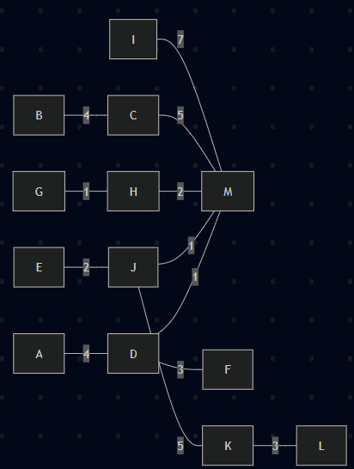
Total weight:

1 + 1 + 1 + 2 + 2 + 3 + 3 + 4 + 4 + 5 + 5 + 7 = 38

3. Uniqueness of the minimum spanning trees

Problem 1 graph:

The minimum spanning tree is unique.

The minimum spanning tree is:

{FI, IE, EB, BH, HC, CD, DA, AG}

There are no other minimum spanning trees.

Reason:
Every edge that is not in the tree is heavier than the largest edge on the unique tree path
between its endpoints. In particular:

AF(7) is heavier than the largest edge on the path A-D-C-H-B-E-I-F, which is 5
DG(6) is heavier than the largest edge on the path D-A-G, which is 3
GI(4) is heavier than the largest edge on the path G-A-D-C-H-B-E-I, which is 3
GH(7) is heavier than the largest edge on the path G-A-D-C-H, which is 3
IH(6) is heavier than the largest edge on the path I-E-B-H, which is 3
FE(6) is heavier than the largest edge on the path F-I-E, which is 5
BC(5) is heavier than the largest edge on the path B-H-C, which is 3

Since every non-tree edge is strictly heavier than the largest edge on the corresponding tree
path, no swap can produce another tree of the same total weight. Therefore, the MST is unique.

Problem 2 graph:

The minimum spanning tree is not unique.

The minimum spanning tree produced by Kruskal is:

{DM, GH, JM, EJ, HM, DF, KL, AD, BC, CM, JK, IM}

The only other minimum spanning tree is:

{DM, GH, JM, EJ, HM, FM, KL, AD, BC, CM, JK, IM}

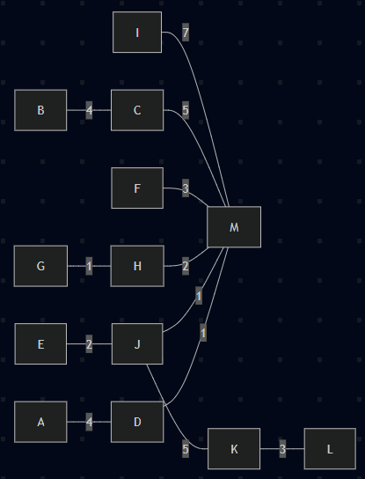
Reason:
All of the selected edges except the edge used to attach F are forced by the cut property.
Vertex F can join the growing tree in exactly two minimum ways: DF(3) or FM(3). Replacing
DF with FM keeps the graph connected and keeps the total weight the same.

So the graph in Problem 2 has exactly two minimum spanning trees, and the only difference
between them is whether F is connected by DF or by FM.

4. Dijkstra's shortest-path algorithm from A

Directed adjacency lists:

A: B(2), C(7), D(6)
B: C(3), F(1)
C: E(3)
D: E(3)
E: F(1)
F: C(3), D(1)

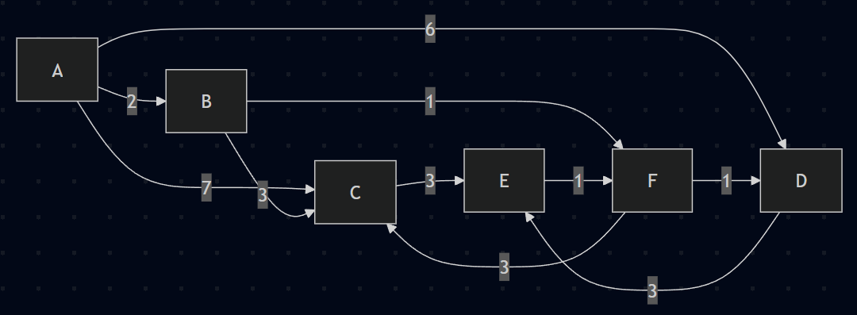
Initialization:

dist(A) = 0
dist(B) = infinity
dist(C) = infinity
dist(D) = infinity
dist(E) = infinity
dist(F) = infinity

pred(A) = none
pred(B) = none
pred(C) = none
pred(D) = none
pred(E) = none
pred(F) = none

Step 1: settle A

Relax edges from A:
B: infinity -> 2 via A
C: infinity -> 7 via A
D: infinity -> 6 via A

Current unsettled distances:
B = 2 via A
C = 7 via A
D = 6 via A
E = infinity
F = infinity

Step 2: settle B

Add AB to the shortest-path tree.

Relax edges from B:
C: 7 -> 5 via B
F: infinity -> 3 via B

Current unsettled distances:
C = 5 via B
D = 6 via A
E = infinity
F = 3 via B

Step 3: settle F

Add BF to the shortest-path tree.

Relax edges from F:
C stays 5 because 3 + 3 = 6 is not better
D: 6 -> 4 via F

Current unsettled distances:
C = 5 via B
D = 4 via F
E = infinity

Step 4: settle D

Add FD to the shortest-path tree.

Relax edges from D:
E: infinity -> 7 via D

Current unsettled distances:
C = 5 via B
E = 7 via D

Step 5: settle C

Add BC to the shortest-path tree.

Relax edges from C:
E stays 7 because 5 + 3 = 8 is not better

Current unsettled distances:
E = 7 via D

Step 6: settle E

Add DE to the shortest-path tree.

Relax edges from E:
F stays 3 because 7 + 1 = 8 is not better

Final shortest-path tree edges in order:

AB, BF, FD, BC, DE

Final shortest-path tree:

{AB, BF, FD, BC, DE}

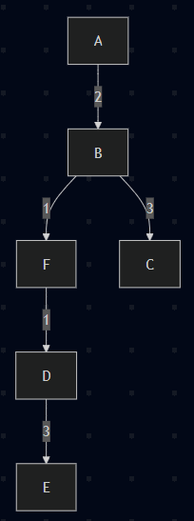
Final shortest-path distances from A:

A = 0
B = 2
F = 3
D = 4
C = 5
E = 7

